AQUA SILENCER

SYNOPSIS
This project is an attempt to reduce the toxic content of diesel exhaust, before it is emitted to the atmosphere. This system can be safely used for diesel power packs which could be used in inflammable atmospheres, such as refineries, chemicals processing industries, open cost mines and other confined areas, which demands the need for diesel power packs.

WORKING PRINCIPLE
The aqua silencer is more effective in the reduction of emission gases from the engine exhaust gas using perforated tube. By using perforated tube the back Pressure. Will remain constant and the sound level is reduced. Using the perforated tube the fuel consumption remains same as conventional system. By using water as a medium the sound can be lowered and also by using activated charcoal in water. We can control the exhaust emission to a grater level. The water contamination is found to be negligible in aqua silencer, because the amount of acidity level in aqua silencer is expected to be below the dangerous acidity. It is smokeless and pollution free emission and also very cheap. The aqua silencer’s performance is almost equivalent to the conventional silencer.
ADVANTAGES
- Diesel engines are playing a vital role in Road and sea transport, Agriculture, mining and many other industries.
- Considering the available fuel resources and the present technological development, Diesel fuel is evidently indispensable
In general, the consumption of fuel is an index for finding out the length of any country
DISADVANTAGE
Need to alter the silencer which may increase the total weight of the vehicle.

APPLICATION
For achieving this toxic gases are to be reduced to acceptable limits before they are emitted out of this atmosphere, which otherwise will be hazardous and prone to accidents.

DRAWING FOR AQUA SILENCER
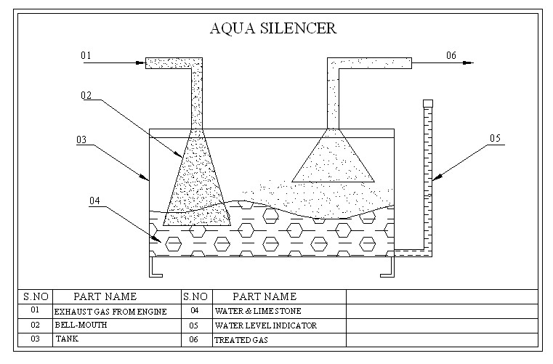

DESIGN

